**WEEK 15 ASSIGNMENT BDWUP**

**ADD A CHART ELEMENT (BAR CHART) IN A REPORT USING PENTAHO REPORT DESIGNER.**

**Aim:**

Adding chart element (033_m2_ds_v.1.0 –sheet 1 excel file)

**Algorithm:**

1.Start the process.

2.Create a data source using Excel.

3.Save the file in CSV format.

4.Open Pentaho Launcher tool for report generation.

5.Import Spread sheet

6. Choose a Area chart for report generation.

7.Give the X axis and Y axis Values for chart.

8.Display the chart report.

9.Save the file.

10.Stop the process.

**OUTPUT:**

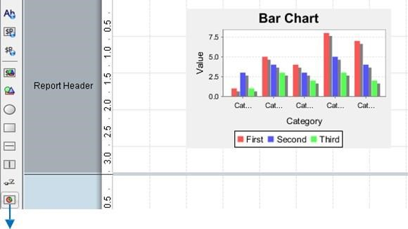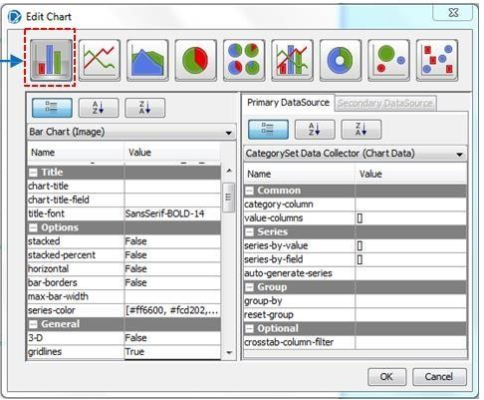

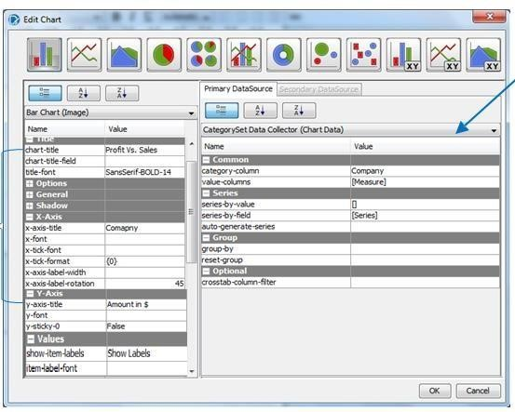

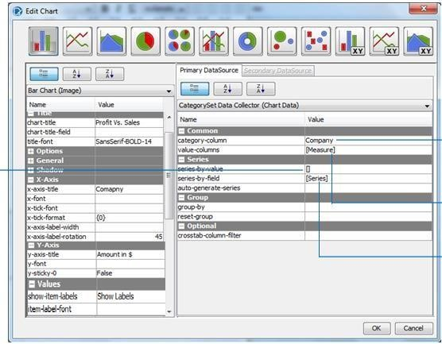

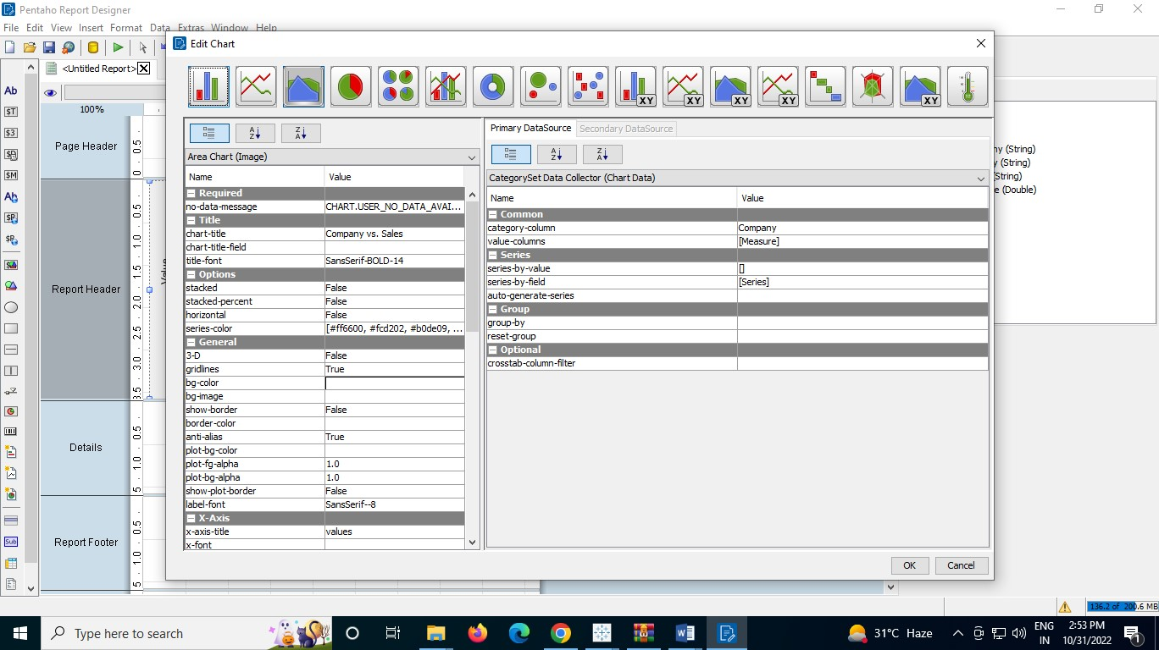

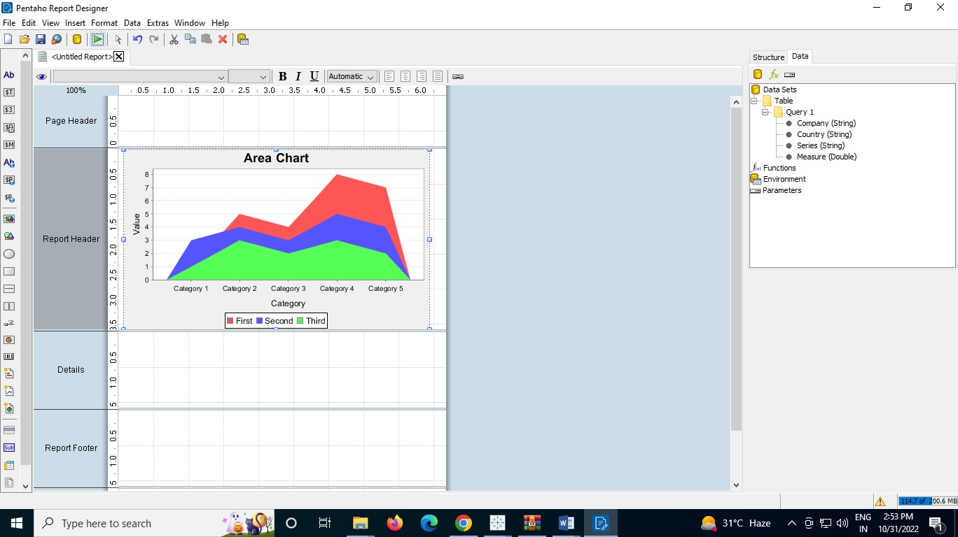

**Result :**

The above termination is executed successfully.